**Solution for Assignment 7**

1. The provided JavaScript code will print as follows in respective order

undefined

8

8

9

10

1

1. Global Scope and Local Scope Definitions

In any JavaScript code, the environment outside all functions is referred as global scope. And variables defined in the global scope are called global variables. These variables are accessible by all functions. On the other hand, the environment inside a function is referred as a local scope and variables defined in this scope are called local variables. These variables are accessible only to their respective scope and to functions nested in that scope.

1. Accessibility of scopes to variables as per the code provided is as follows respectively.

1. No

2. yes

3. no

4. yes

5. yes

1. Based to the code provided the following will be printed respectively

81

25

1. Based on the code provided alert will print

10

1. The provided code can be modified as follows to create an object with extra functionality

var count = (function() {

var counter = 0;

return {

‘add’ : function () { counter++; },

‘reset’: function() {counter = 0; }

};

})();

1. From the code given in number 6 above, the free variable is counter. In any function, variables defined outside the scope of that function and not parameters of that function if get used inside the function they are referred as free variables.
2. Write make_adder(inc)

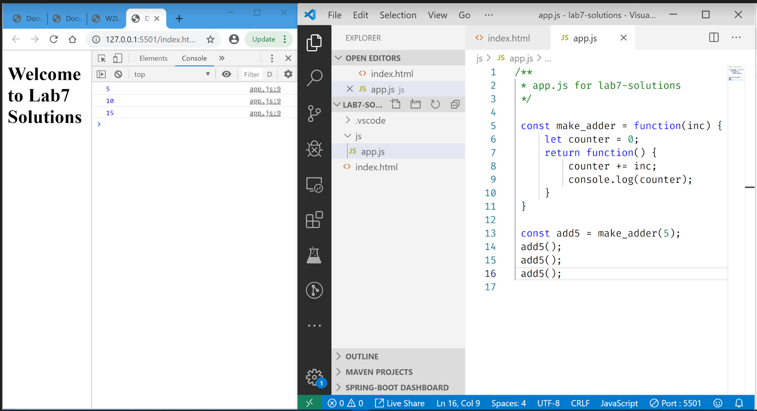

1. What simple modification can keep global scope clean:

Using IIFE and wrapping the whole code as a module.

1. Use revealing module to create Employee object:

Please download the full sample code solution from the folder named, Q10.

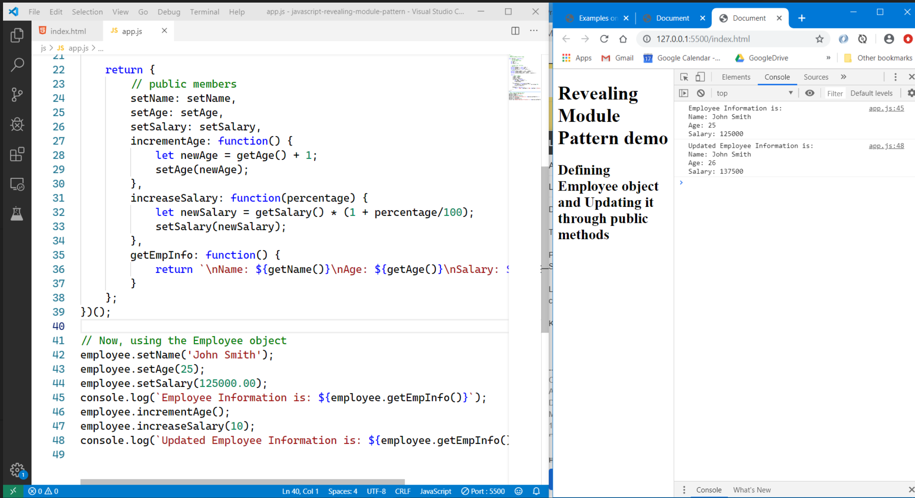

1. Extend question 10’s employee object to have a public address and public get/setAddress methods.

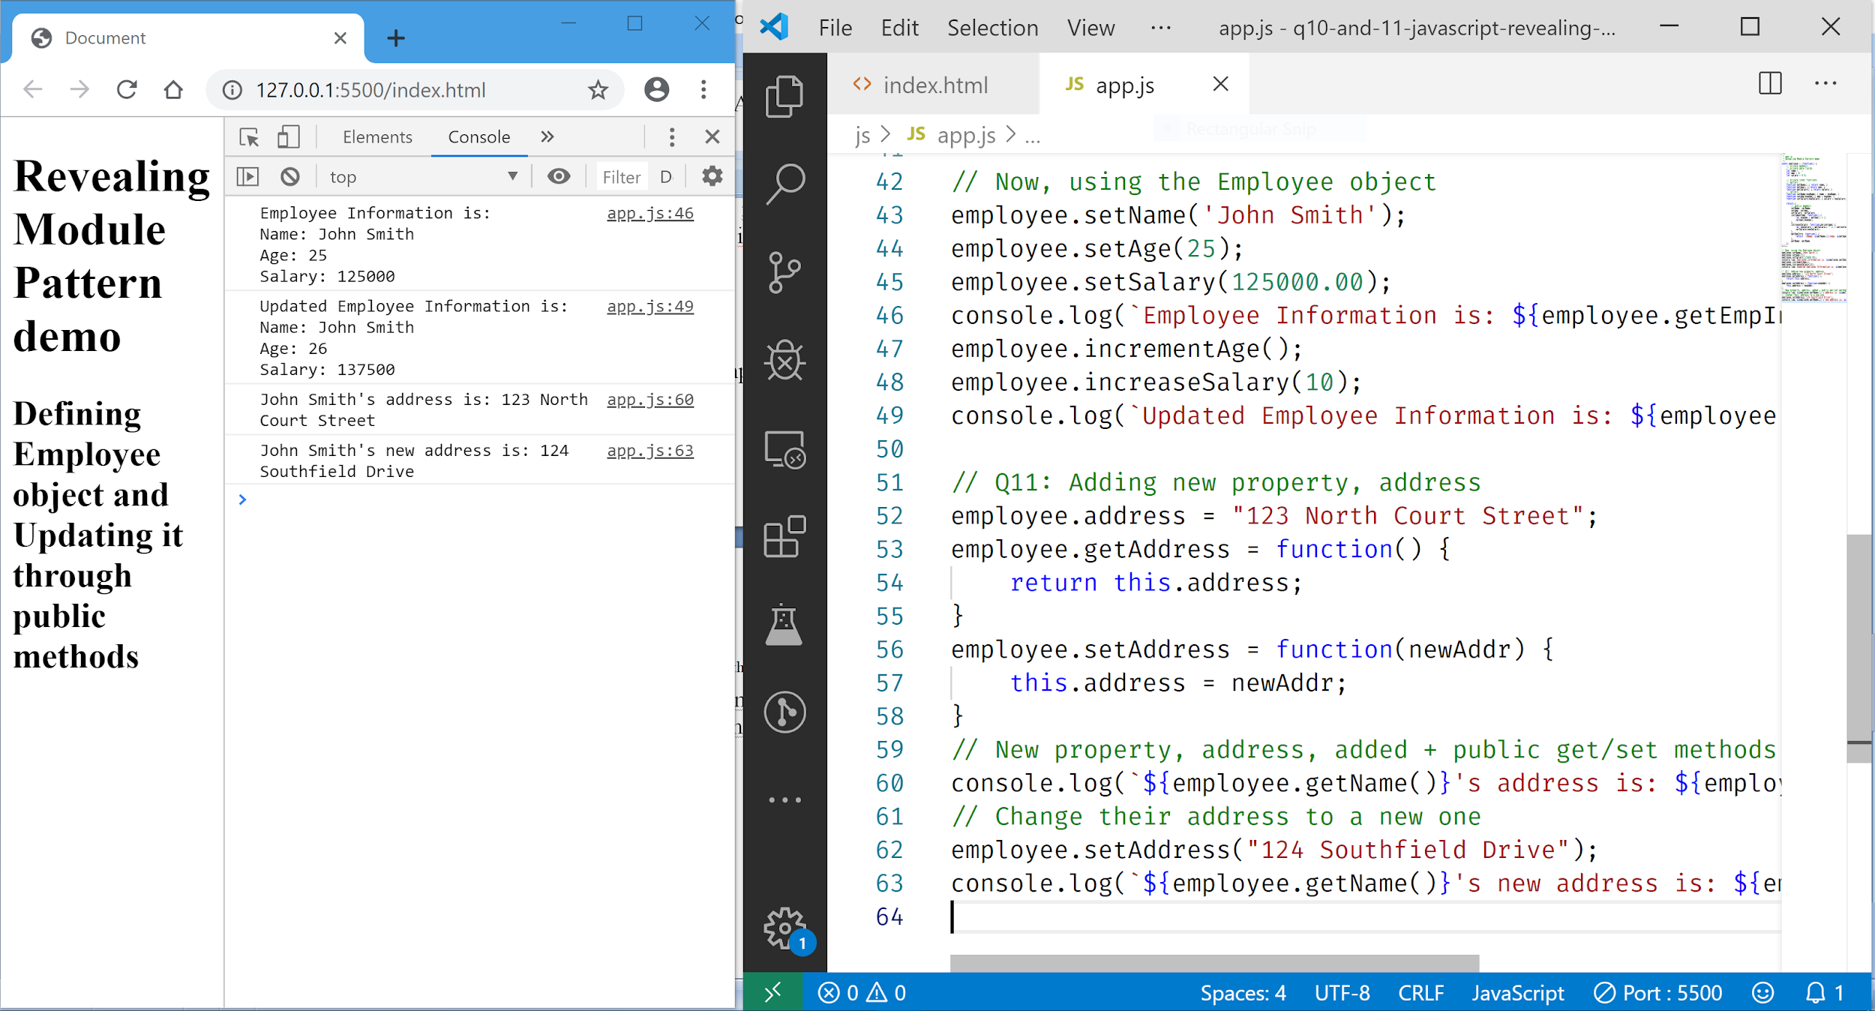

**//-- Fin : The End --//**

1. qqqw